m

**CC-215-L: Database Systems Lab**

*Faculty of Computing & Information Technology*



**BS(CS) Morning - Fall 2021, Semester Fall 2023**

**LAB – 03**

# Topics

* Single row functions for Date, number and char functions
* Conversion functions

# Learning Objectives

* Develop the fundamental skills of row functions
* Performing row functions for Date , numbers and char
* Preforming different conversions using conversions functions

# General Instructions:

* In this Lab, you are **NOT** allowed to discuss your solution with your colleagues, even not allowed to ask how s/he is doing; this may result in negative marking. You can **ONLY** discuss with your Teaching Assistants (TAs) or Lab Instructor.
* Your TAs will be available in the Lab for your help. Alternatively, you can send your queries via email to one of the followings.

|  |  |  |
| --- | --- | --- |
| **Lab Instructors** | | |
| Course Instructor | Dr. Asif Sohail | [asif@pucit.edu.pk](mailto:asif@pucit.edu.pk) |
| Teaching Assistants | Kabeer Ali | [bitf20m018@pucit.edu.pk](mailto:bitf20m018@pucit.edu.pk) |
| Hamza Farooqi | [bitf20m031@pucit.edu.pk](mailto:bitf20m031@pucit.edu.pk) |

Hope you are fine and feeling yourself comfortable and exciting to play with Structured Query Language (SQL) in this first lab. *You have been taught in the lecture about SQL and query writing. Why not to get all what you have learned with a hands-on experience?* So, let’s Start!

*Allowed time: 1.5 hour*

***Note: Do follow these instructions while you are sitting in the lab and performing the tasks.***

1. ***Gossips are not allowed. So be gentle and do what you know. The lab is not to deduct your sessional marks but to prepare you to achieve good marks in quizzes, mids and finals and finally have good grades. So, try to perform all your tasks in time and at your own.***
2. ***Teacher assistants are for your help, so be nice with them. Respect them as they are teaching you. Raise your hands if you have some problem and need help from TA. Avoid calling them by raising your voice and disturbing the environment of Lab.***
3. ***You must revise the content of the past lectures before starting the lab, it will help you resolve most of your general queries and give you the confidence that you can do it.***
4. ***Evaluation will be considered final and you cannot debate for the marks. So, focus on performing the tasks when the time is given to you.***
5. ***TA may deduct your marks for any kind of ill-discipline or misconduct from your side.***
6. ***Finally, pray before you start. And, Best of Luck!***

* **Kindly paste the query as well as result table screenshot as a result of each task**

**Sample:**

**Display All the Employees from emp table**

**Solution:**

**Select * from emp**

|  |  |  |  |  |  |  |  |
| --- | --- | --- | --- | --- | --- | --- | --- |
| **EMPNO** | **ENAME** | **JOB** | **MGR** | **HIREDATE** | **SAL** | **COMM** | **DEPTNO** |
| 7369 | SMITH | CLERK | 7902 | 12/17/1980 | 800 | - | 20 |
| 7499 | ALLEN | SALESMAN | 7698 | 02/20/1981 | 1600 | 300 | 30 |
| 7521 | WARD | SALESMAN | 7698 | 02/22/1981 | 1250 | 500 | 30 |
| 7566 | JONES | MANAGER | 7839 | 04/02/1981 | 2975 | - | 20 |
| 7654 | MARTIN | SALESMAN | 7698 | 09/28/1981 | 1250 | 1400 | 30 |

**Task 01: [15 Marks]**

1. List the names and job titles of all employees with the first letter capitalized, like 'Smith', for both columns.

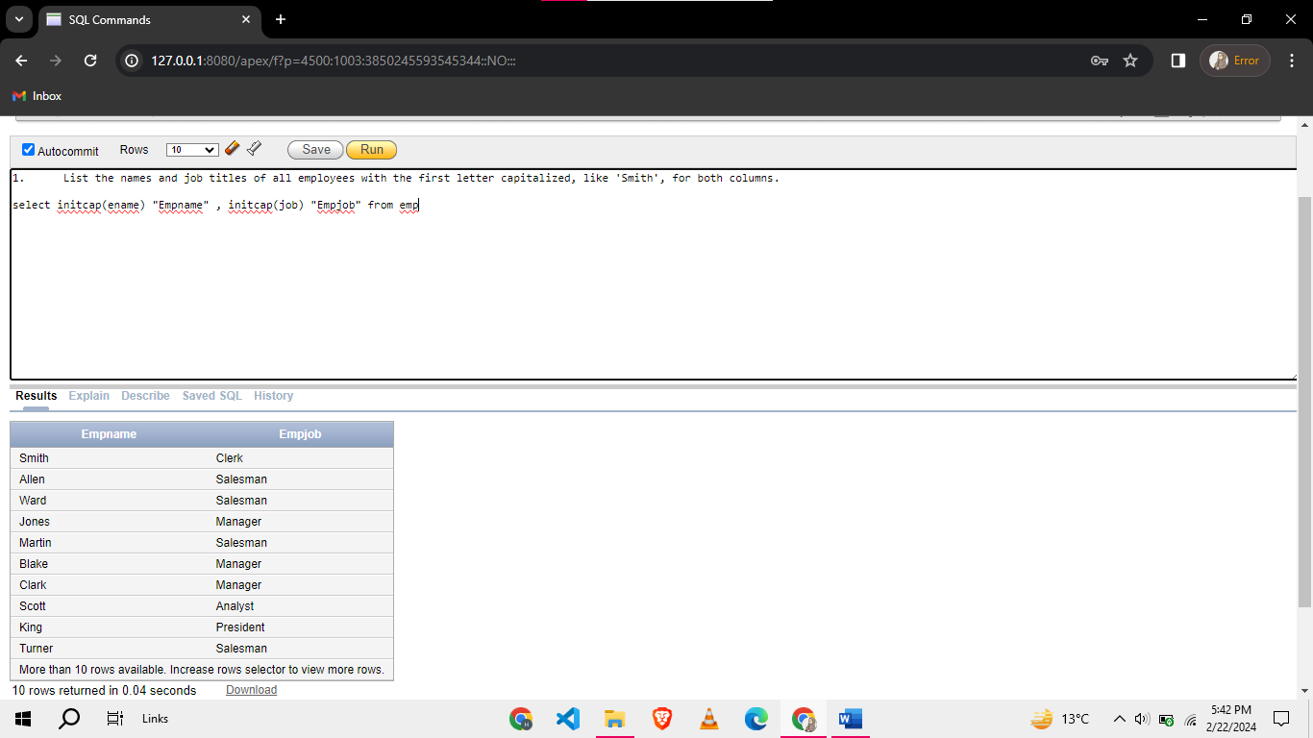

1. Display the hire date and the name of the day on which each employee was hired for all employees in the emp table.

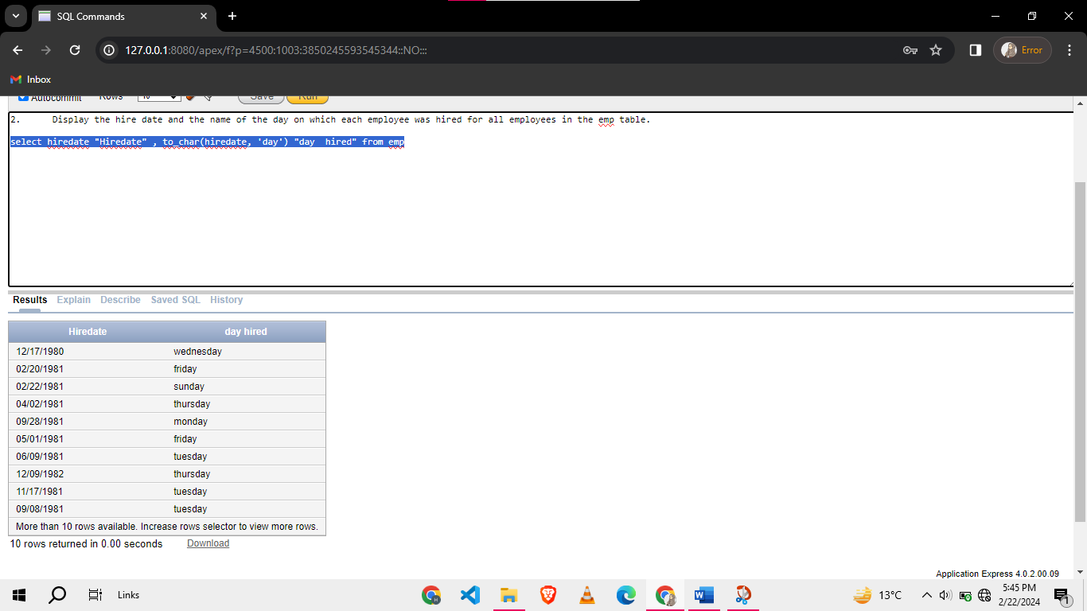

1. Show the names, salaries, and commission of employees, displaying 'No Commission' for those with null commission.

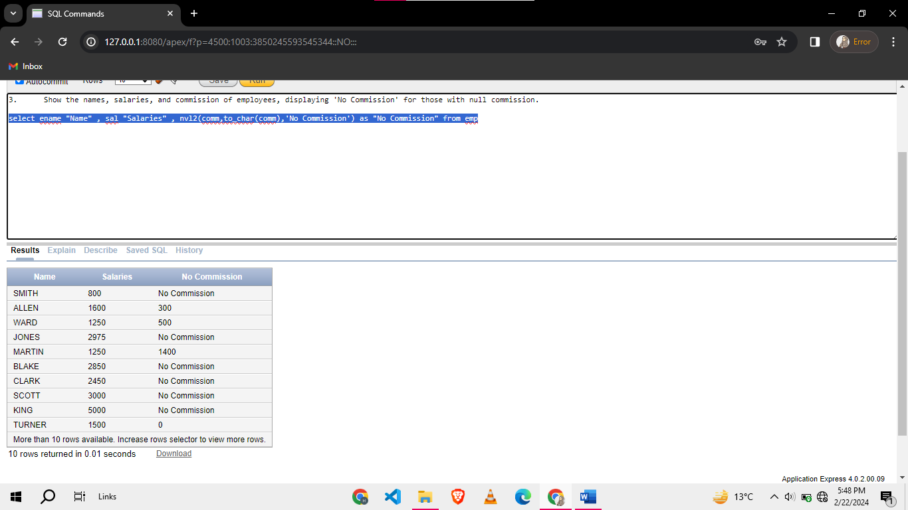

1. Convert the job titles of all employees to lowercase and display the results.

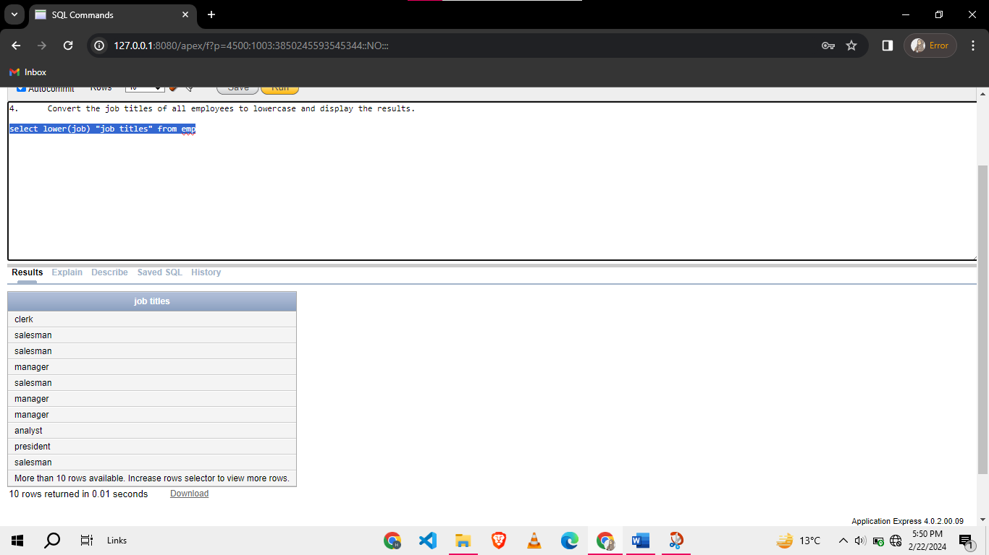

1. Extract the last four characters of the department names from the DEPT table and display the results.

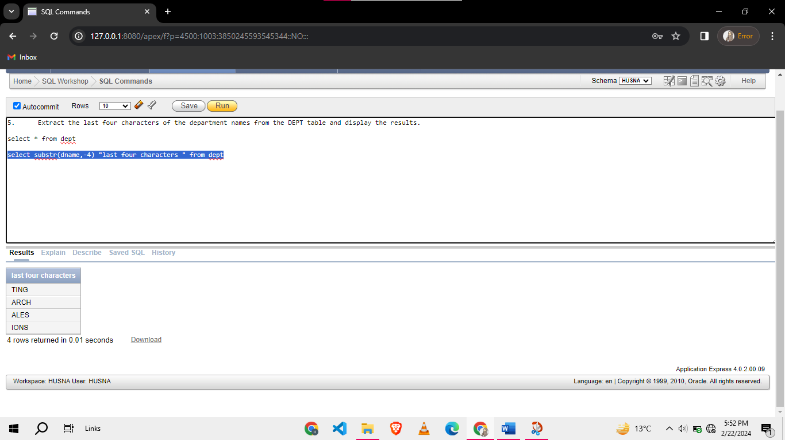

1. Display the salaries, squared salaries, and square roots of the salaries of employees.

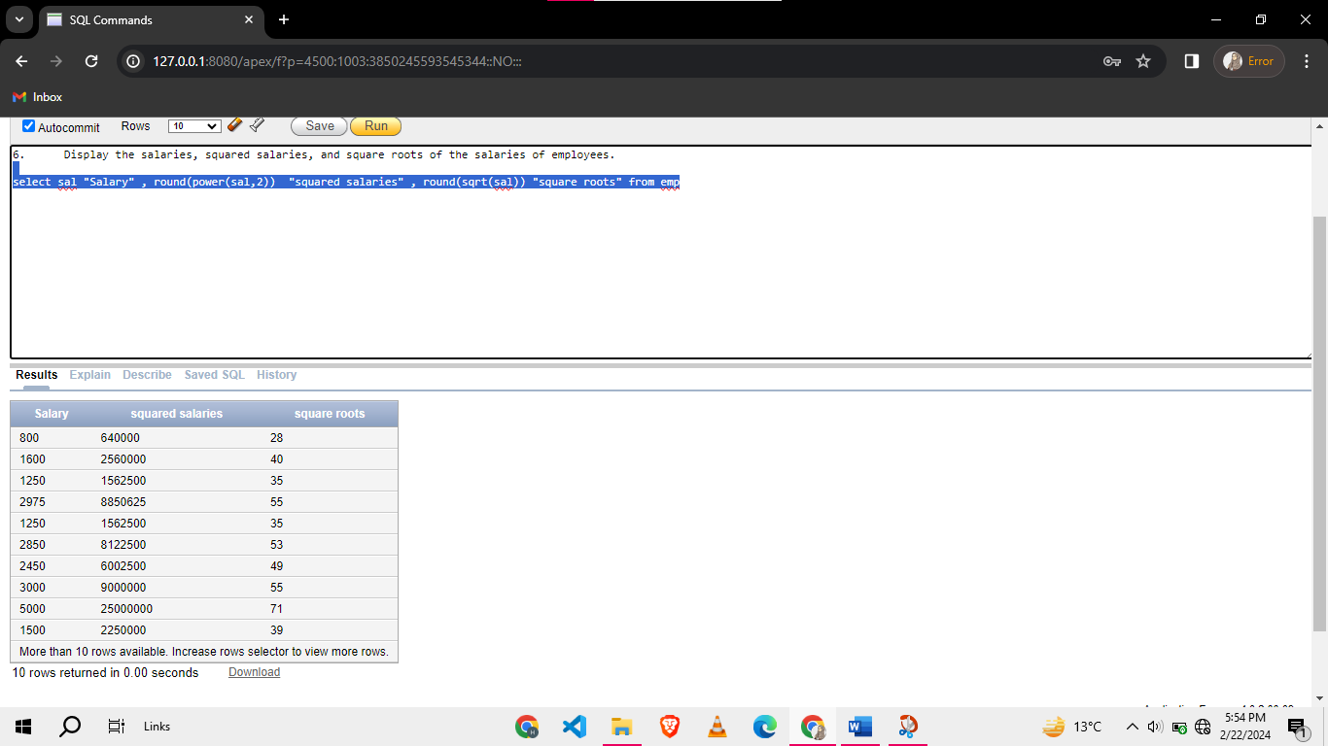

1. Display the names, job titles, length of the names, and length of the job titles of all employees.

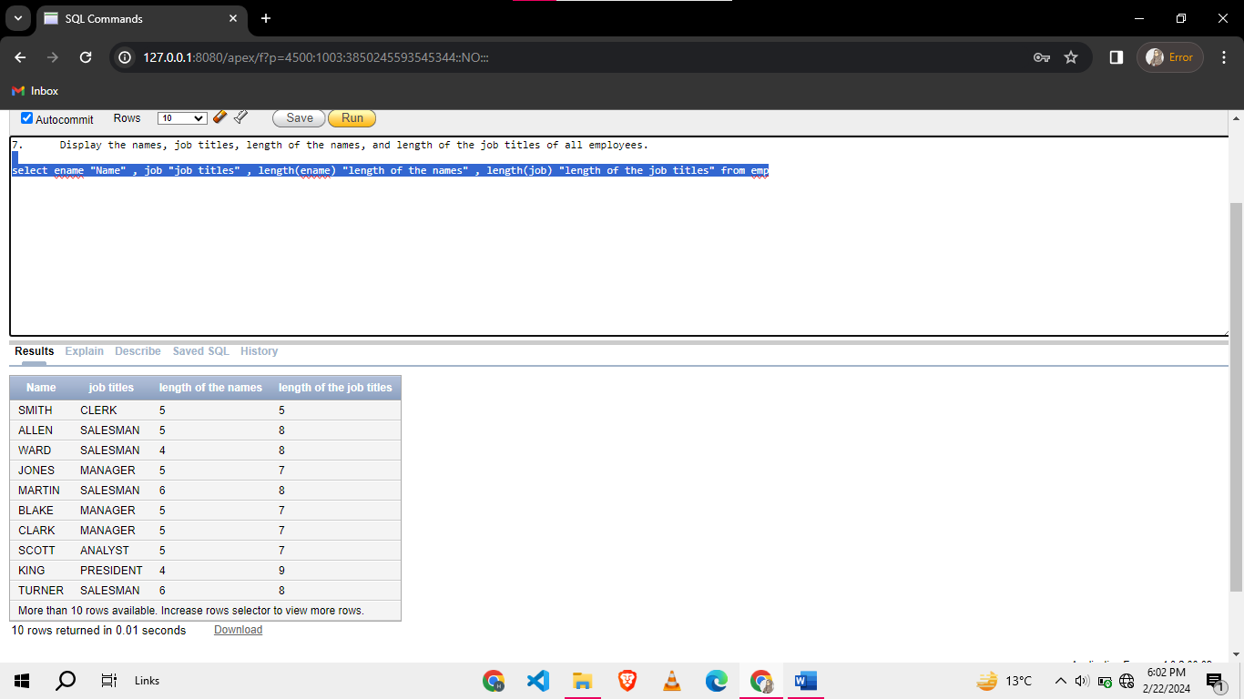

1. Display the employee number, employee name and 1-day salary without decimals for all employees in emp excluding manager.

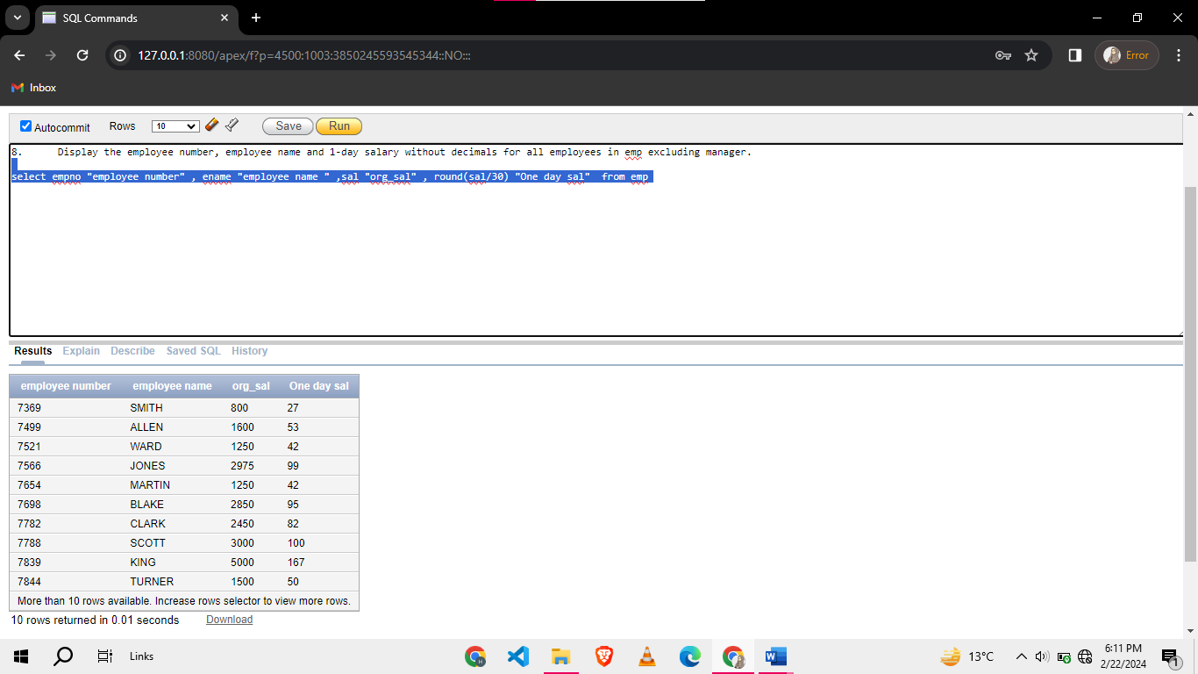

1. List employees who have been employed for more than 5 years and have a commission greater than 600, ordered by their commission percentage in descending order.

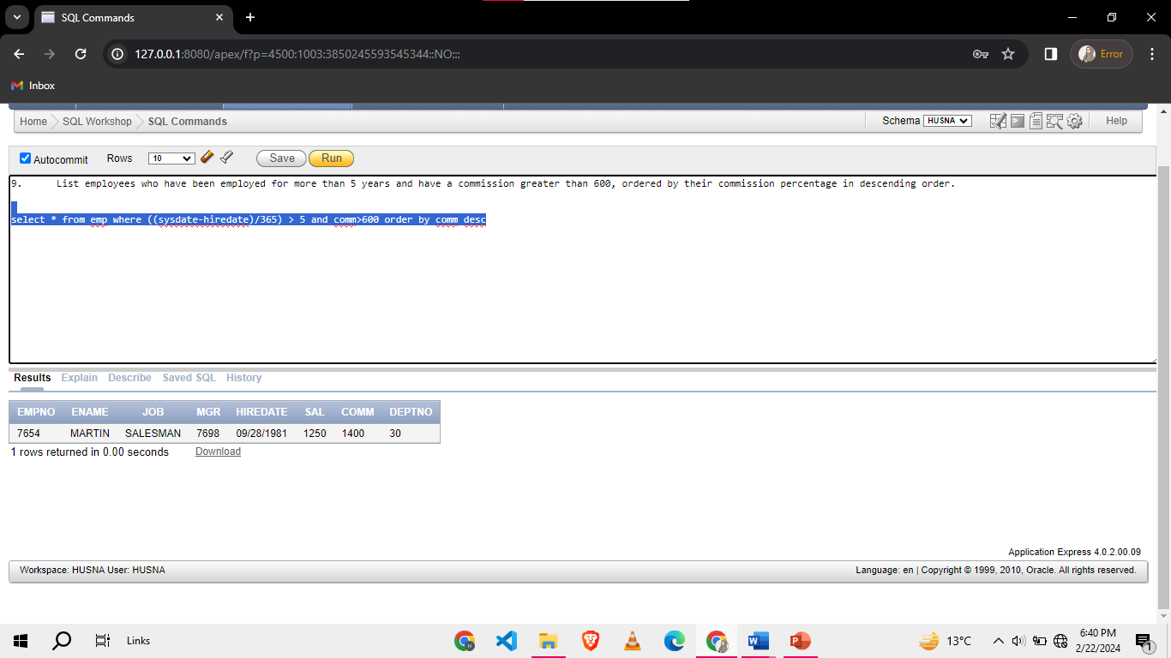

1. List employees who have not been assigned to any department.

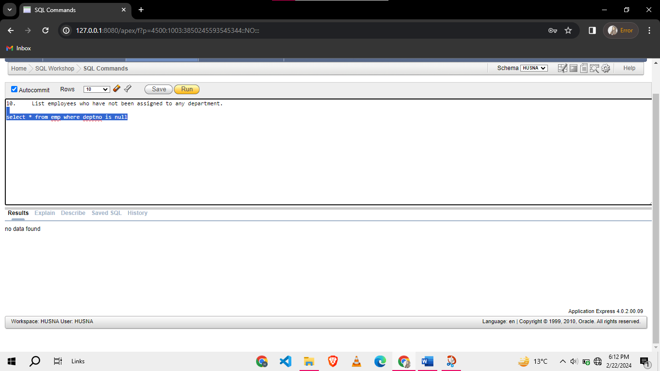

1. Display the service of each employee in days, weeks, and months in separate columns.

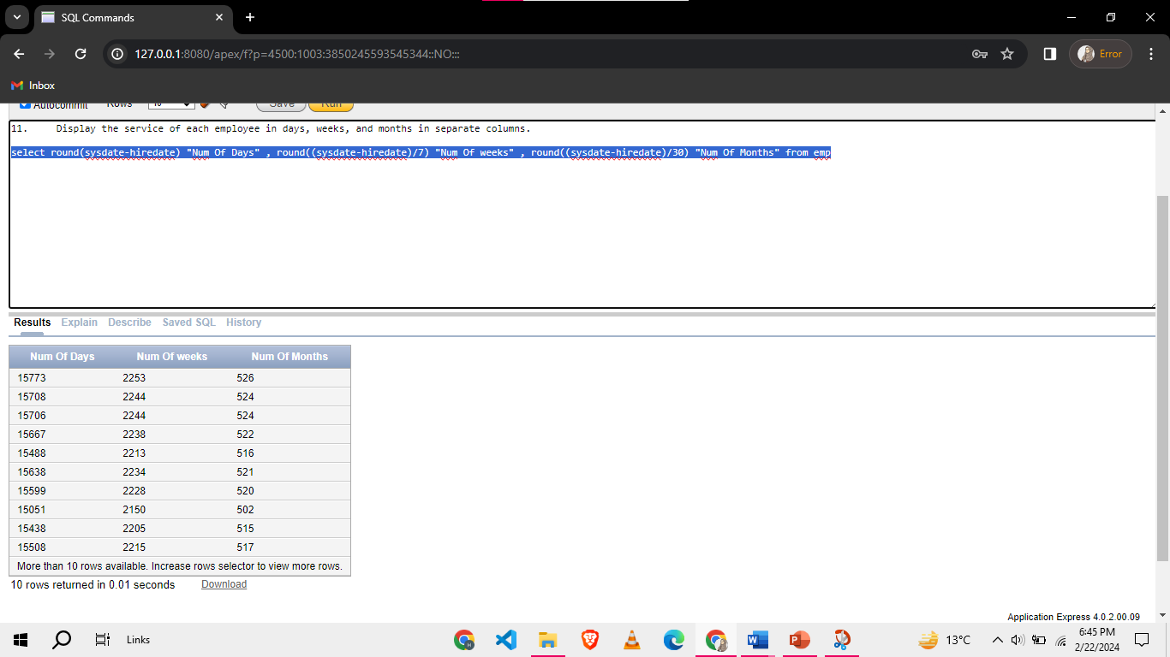

1. Write a query to display the date when our next lab is scheduled.

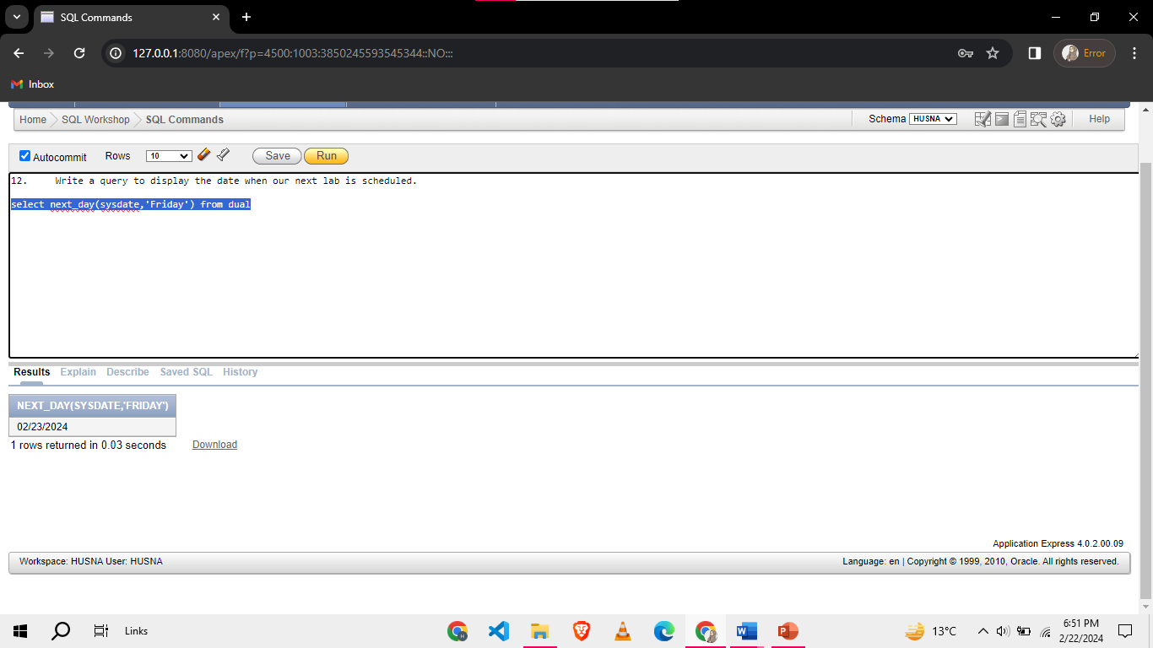

1. Display the last day of the month for the hire date of each employee.

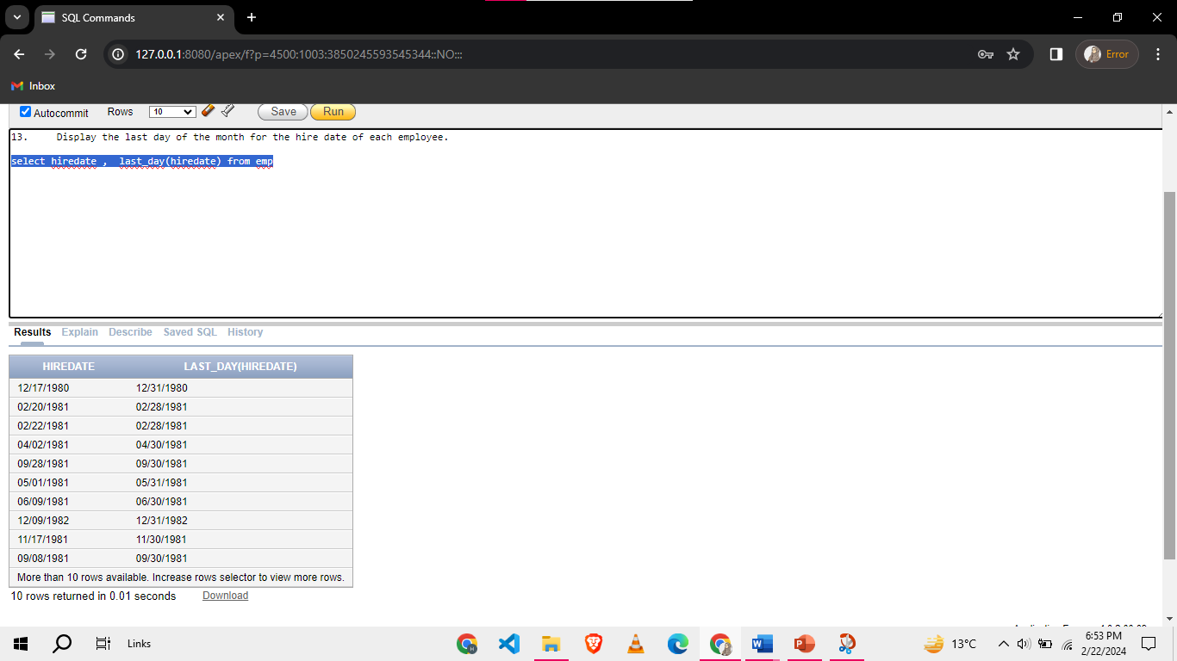

1. Display EMPNO, ENAME, JOB, SAL, and the hire year of all employees working in DEPTNO 10 or 30 who do not have any manager.

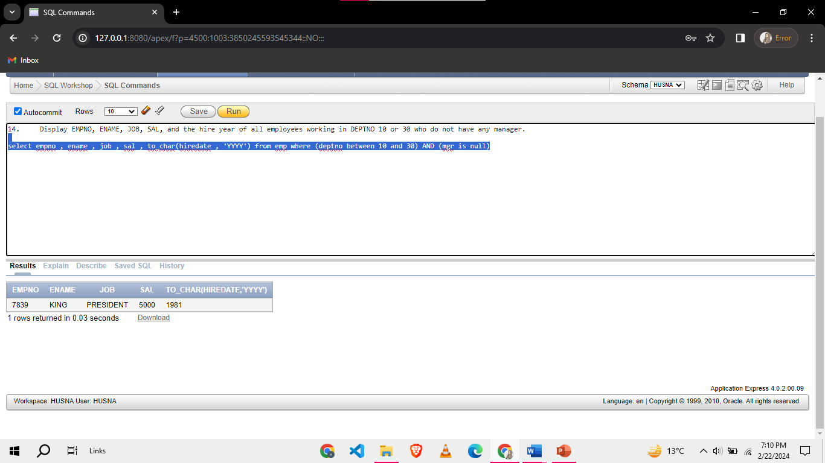

1. Concatenate the first three characters of each employee's name with their salary, separated by a hyphen.

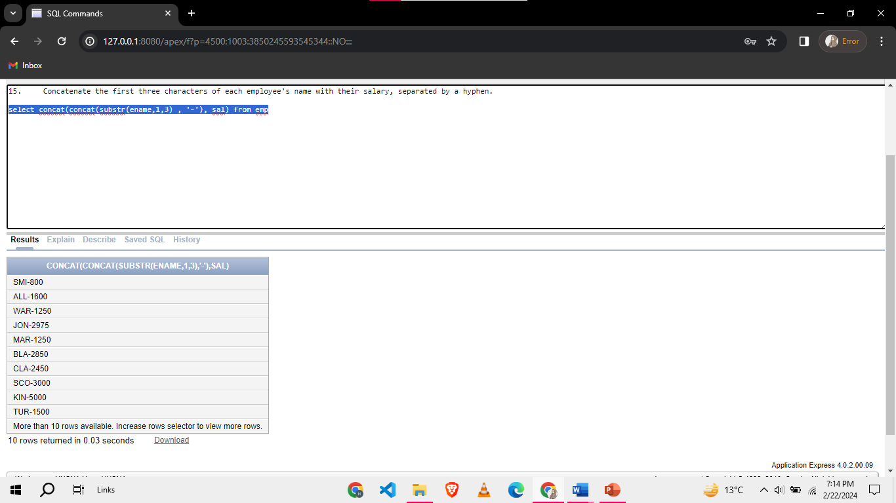

**Task 02: [10 Marks]**

1. Write a SQL query to find those employees who joined in any month, but the name of the month contains the character 'A' in the second position.

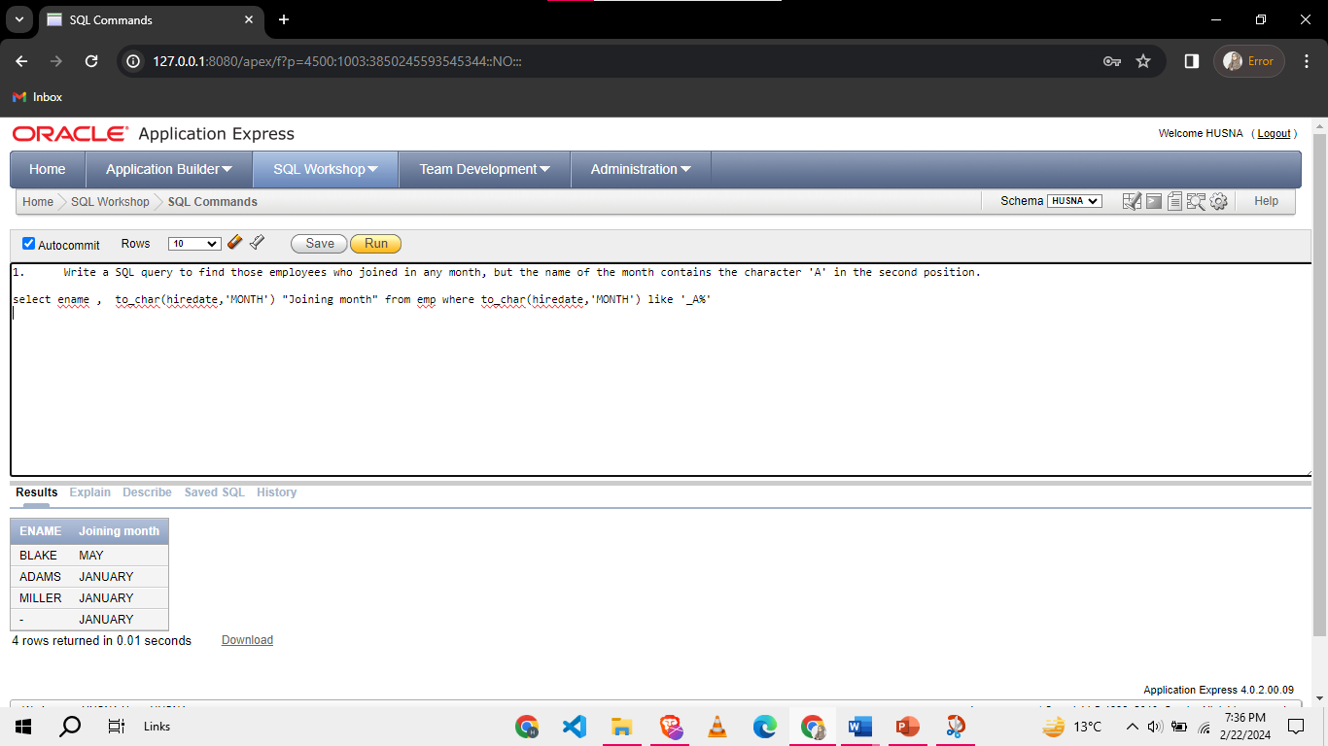

1. Find the experience of all the employees in years and months. The output of the query should be like “Experience of <ename> is Y years and M months.”

NOTE: YOU MUST NOT USE ‘||’ OPERATOR

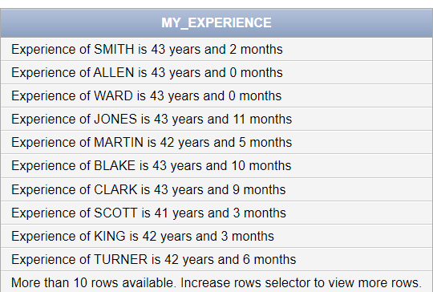

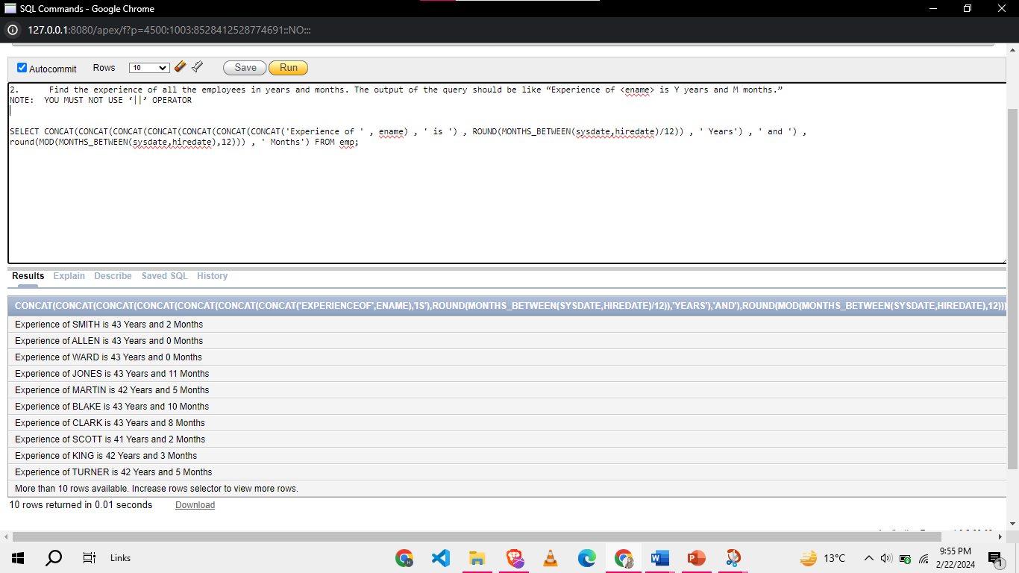

1. Write an SQL query to find the number of occurrences of letter “T” in every name of employee

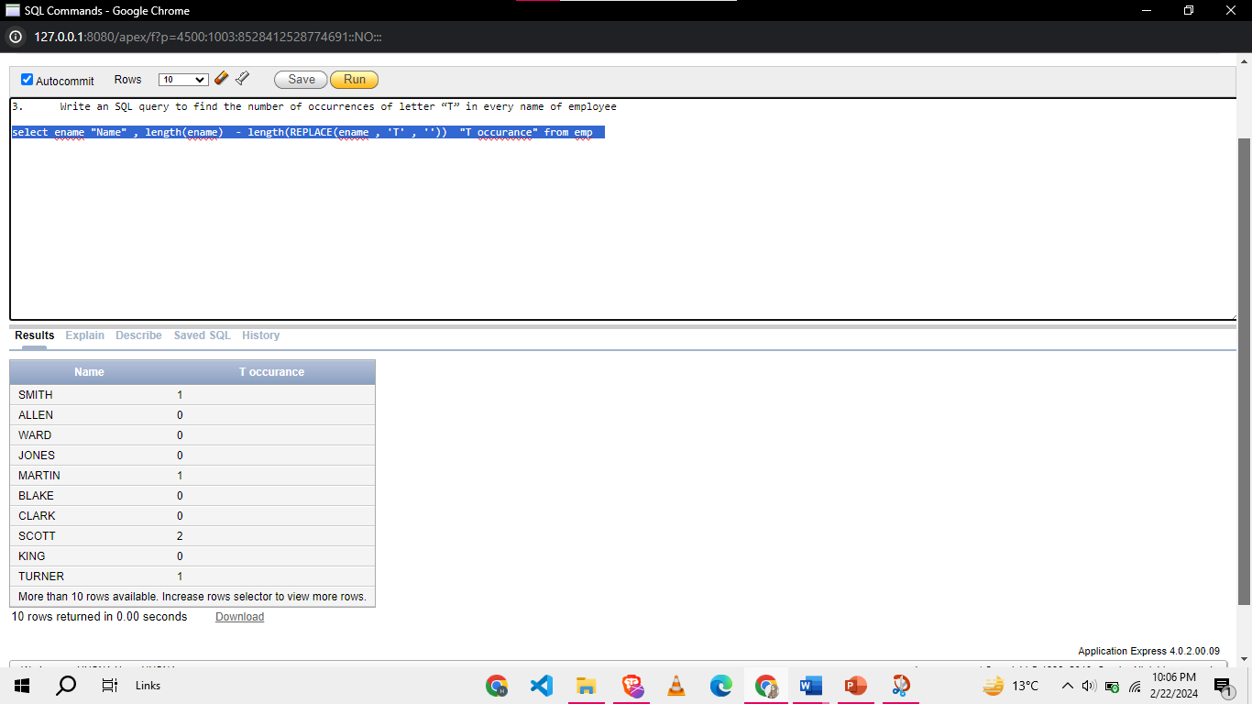

1. Get firstname of the student from the column std_name(PUCIT table) like if std_name “Kabeer Ali”,output=Kabeer.

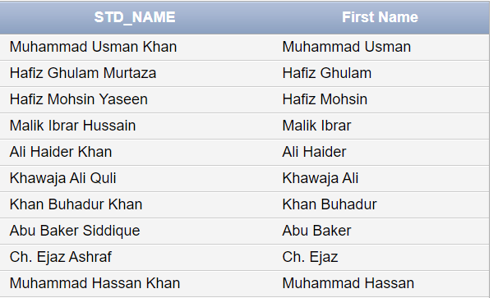

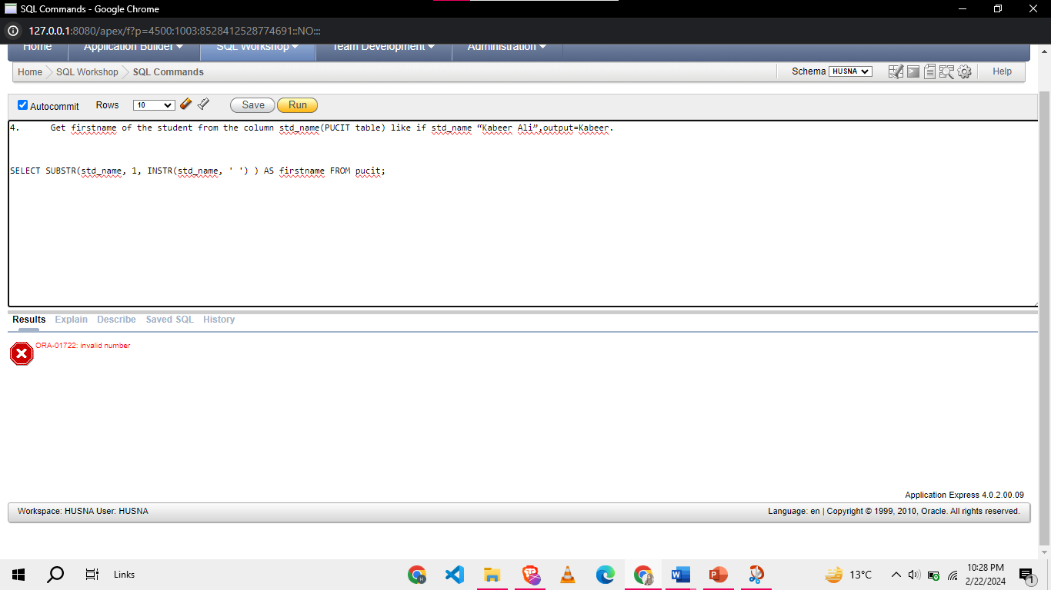

1. Replace all occurrences of 'SALESMAN' in the job titles with 'REPRESENTATIVE' and display the updated job titles

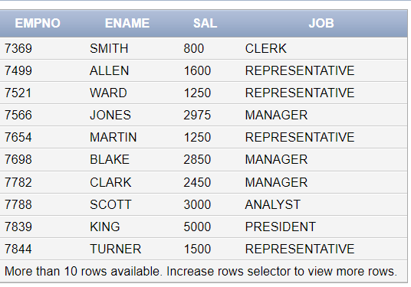

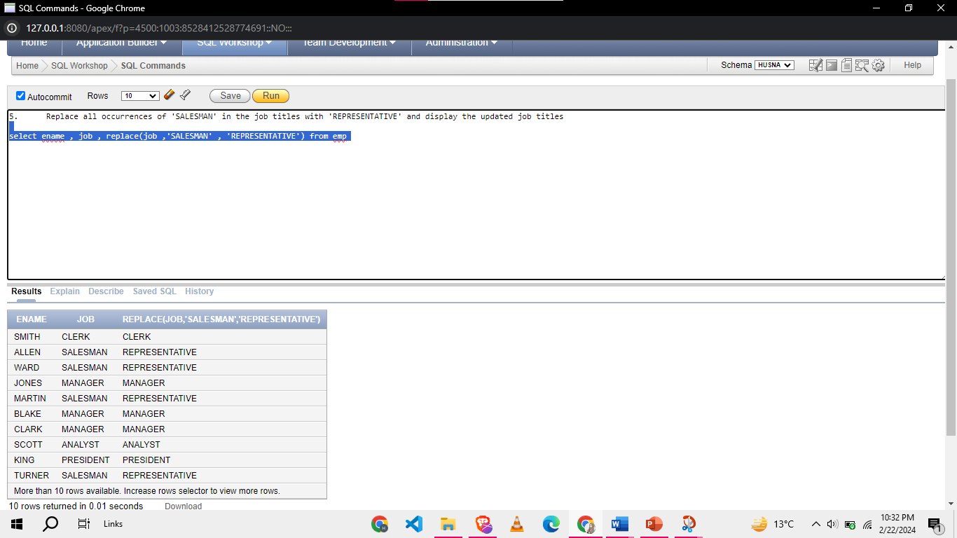

**Task 03: [15 Marks]**

1. Write an SQL query to retrieve the employee number, employee ename, job title, and a modified job title AS Modified_Job for employees. The modified job title should be obtained by removing the first character of the original job title and appending that word at the last like

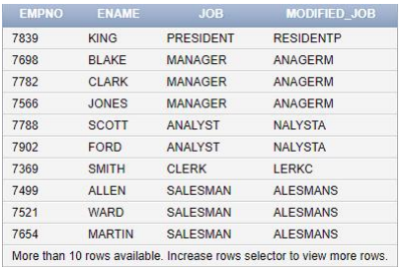

1. Display ENAME, SAL, and Updated Name (derived column). The Updated Name column has last 2 alphabets from ename and appends asterisk (‘*’) at the right, with each asterisk signifying a 500 dollar. For example, 3starts should output for all the employee with salary in the range 100to 5000. Sort the output in descending order of SAL

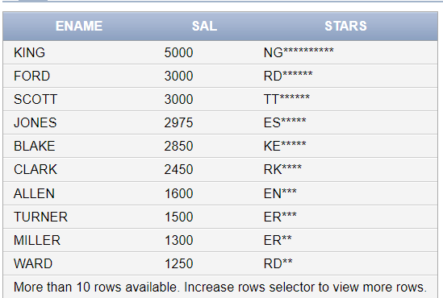

1. Write a query to display all the employees without letter ‘A’

**NOTE: you are not allowed to use ‘like’ operator**

1. List all the employees hired in leap years.
2. Write a query that display’s CODE of each student of table pucit in the following Format “3 LETTERS OF middle Name from pos3 to pos5_XD”

Example the code for

**“mr hussain nasir” will be ssa_XD**

**“Ali Haider Khan” will be ide_XD**

NOTE: YOU MUST NOT USE ‘||’ OPERATOR

**Task 04: [5 Marks]**

**Viva Questions**